**SDM COLLEGE OF ENGINEERING AND TECHNOLOGY**

Dhavalagiri, Dharwad-580002, Karnataka State, India.

**Email: cse.sdmcet@gmail.com**

DEPARTMENT OF COMPUTER SCIENCE AND ENGINEERING

**A** **R****eport**

**on**

**DBMS- Minor Work**

**COURSE CODE:** **22UCSC501 COURSE TITLE: DBMS**

**SEMESTER: V DIVISION: A**

**COURSE TEACHER: Dr. U. P. Kulkarni**



**[ Academic Year- 2023-24]**

**Date of Submission: 19/12/2024**

Submitted

By

**Mr. Pratham M**

**USN: 2SD22CS063**

**Table of Contents**

**Minor Work: -** 3

**Problem statement 1**: - **Write a C program to discuss to demonstrate all the functions related to system calls in Unix based OS.** 3

**Problem Statement 2: - Write a C program to demonstrate the indexing and its associated properties.** 7

**Problem Statement 3: - Write a Java program to access the given Excel file with known file format** 9

# **Minor Work: -**

## **Problem statement 1**: - **Write a C program to discuss to demonstrate all the functions related to system calls in Unix based OS.**

//A simple C program to showcase the System calls in Unix based OS systems

#include <stdio.h>

#include <fcntl.h>

#include <unistd.h>

#include <sys/stat.h>

#include <string.h>

#include <stdlib.h>

#define SIZE 100

char* readFile(char *str);

void writeFile(char *str);

void appendFile(char *str);

int main(){

    int choice;

    char str[SIZE];

    printf("Enter (1-read) (2-write) (3-append) file\n");

    printf("Enter your choice\n");

    scanf("%d",&choice);

    getchar();

    switch (choice)

    {

    case 1:

        printf("Enter the file name to read\n");

        scanf("%s",str);

        getchar(); //clr the I/P stream

        printf("The contents of the file are:\n%s\n",readFile(str));

        break;

    case 2:

        printf("Enter the file name to write\n");

        scanf("%s",str);

        getchar();

        writeFile(str);

        break;

    case 3:

        printf("Enter the file name to appended\n");

        scanf("%s",str);

        getchar();

        appendFile(str);

        break;

    default:

        break;

    }

    return 0;

}

void writeFile(char *filename){

    fflush(stdin);

    int fd = open(filename, O_CREAT | O_WRONLY | O_TRUNC, S_IRUSR | S_IWUSR);

    if(fd < 0){

        perror("Error occured while opning the file\n");

        close(fd);

        return;

    }

    char str[SIZE];

    printf("Enter the string to be writen\n");

    fgets(str, SIZE, stdin);

    write(fd, str, strlen(str));

    close(fd);

}

char *readFile(char *filename){

    char *str = (char *)malloc(SIZE*sizeof(char));

    int fd = open(filename, O_RDONLY);

    if(fd < 0){

        perror("Can't open this file\n");

        free(str);

        close(fd);

        return NULL;

    }

    int bytesRead = read(fd, str, SIZE-1);

    str[bytesRead] = '\0';

    close(fd);

    return str;

}

void appendFile(char *filename){

int fd = open(filename, O_WRONLY | O_APPEND | O_CREAT, S_IRUSR | S_IWUSR);

  if(fd < 0){

        perror("Can't append to the file\n");

        close(fd);

        return;

    }

    char str[SIZE];

    fflush(stdin);

    printf("Enter the String to appended\n");

    fgets(str, SIZE, stdin);

    write(fd, str, strlen(str));

}

O/P: -

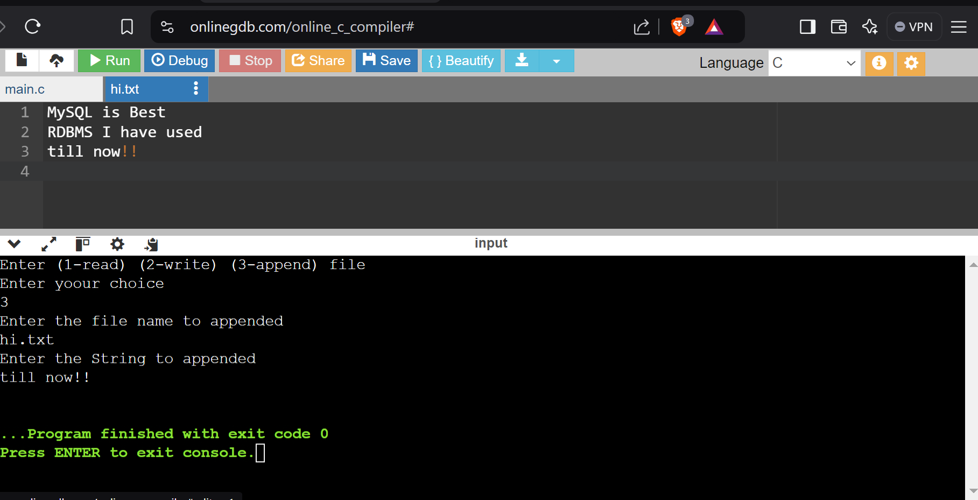

Figure 1.1 – Appending to the file

## **Problem Statement 2: - Write a C program to demonstrate the indexing and its associated properties.**

//A simple C pgm to read and print the details of the employees

#include<stdio.h>

#include<stdlib.h>

#define SIZE 30

#define ECOUNT 10

typedef struct Employee{

    int empID;

    char name[SIZE];

    float salary;

}Employee;

void readEmployeeDetails(Employee *e, int n){

    for(int i=0; i<n; i++){

        printf("Enter the employee %d details\n", i+1);

        printf("Enter the employee id\n");

        scanf("%d",&e[i].empID);

         printf("Enter the employee name\n");

        scanf("%s",&e[i].name);

        printf("Enter the employee salary\n\n");

        scanf("%s",&e[i].salary);

    }

}

void printEmployeeDetails(Employee *e, int n){

    for(int i=0; i<n; i++){

        printf("EMPID : %d\n",e[i].empID);

        printf("EMP Name : %d\n",e[i].name);

        printf("EMP Salary : %d\n\n",e[i].salary);

    }

}

int main(){

    Employee e[ECOUNT];

    int n;

    printf("Enter the no of employees\n");

    scanf("%d",&n);

    if(n > ECOUNT){

        printf("max employees = %d\n", ECOUNT);

        exit(0);

    }

    readEmployeeDetails(e, n);

    printEmployeeDetails(e, n);

    return 0;

}

## **Problem Statement 3: - Write a Java program to access the given Excel file with known file format**

package DBMS_Demo.ExcelSheets;

import org.apache.poi.ss.usermodel.*;

import org.apache.poi.xssf.usermodel.XSSFWorkbook;

//import java.io.FileInputStream;

//import java.io.IOException;

import java.io.*;

import java.util.*;

public class ReadWriteXExcel {

public static void readExcelSheet(String filePath) {

try (FileInputStream fis = new FileInputStream(filePath);

Workbook workbook = new XSSFWorkbook(fis)) { //if you declare inside the try then no need to close the fis & workbook externally it will be automatically closed

Sheet sheet = workbook.getSheetAt(0); // Get the first sheet

for (Row row : sheet) {

for (Cell cell : row) {

switch (cell.getCellType()) {

case STRING:

System.out.print(cell.getStringCellValue() + "\t");

break;

case NUMERIC:

System.out.print(cell.getNumericCellValue() + "\t");

break;

case BOOLEAN:

System.out.print(cell.getBooleanCellValue() + "\t");

break;

default:

System.out.print("UNKNOWN\t");

break;

}

}

System.out.println();

}

} catch (IOException e) {

e.printStackTrace();

}

}

//Appending the file

public static void appendFile(String filePath) {

try (FileInputStream fis = new FileInputStream(filePath);

Workbook workbook = new XSSFWorkbook(fis)) {

// Access the existing sheet or create a new one if it doesn't exist

Sheet sheet = workbook.getSheetAt(0); // Use the first sheet

// Determine the next row index (one after the last row)

int nextRowIndex = sheet.getLastRowNum() + 1;

// Create a new row

Row newRow = sheet.createRow(nextRowIndex);

// Create new cells and set values

// Cell cell1 = newRow.createCell(0);

// Cell cell2 = newRow.createCell(1);

Scanner sc = new Scanner(System.in);

int columnsCount = sheet.getRow(1).getLastCellNum();

for(int i=0; i<columnsCount; i++) {

Cell cell = newRow.createCell(i);

System.out.println("Enter the " + (i+1) + " cell value");

cell.setCellValue(sc.next());

}

// Write the changes to the file

try (FileOutputStream fos = new FileOutputStream(filePath)) {

workbook.write(fos);

}

} catch (IOException e) {

e.printStackTrace();

}

}

public static void main(String[] args) {

String filePath = "D:\\Github\\DBMS Assignment\\Book1.xlsx"; // Path to your Excel file

readExcelSheet(filePath);

appendFile(filePath);

}

}

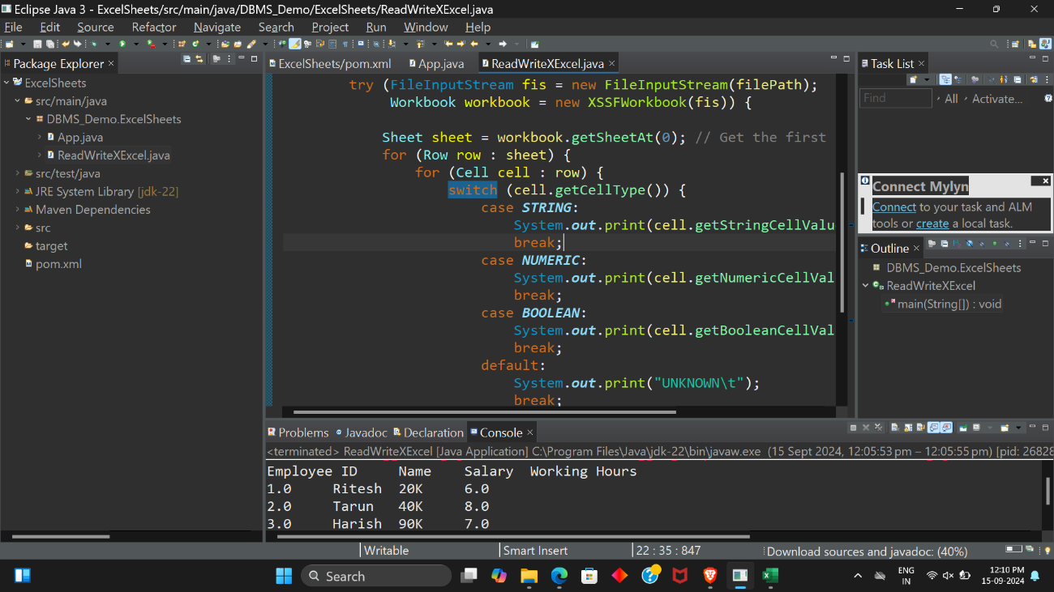

Figure 3.1 – R/W operations on Excel file

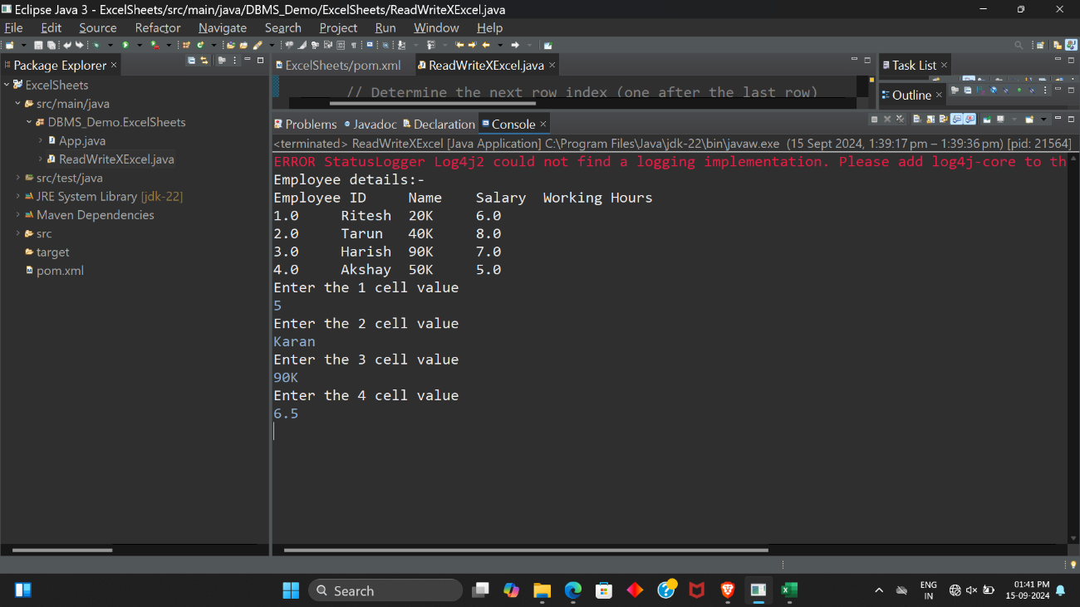

Figure 3.2 – Inserting values into Excel sheet

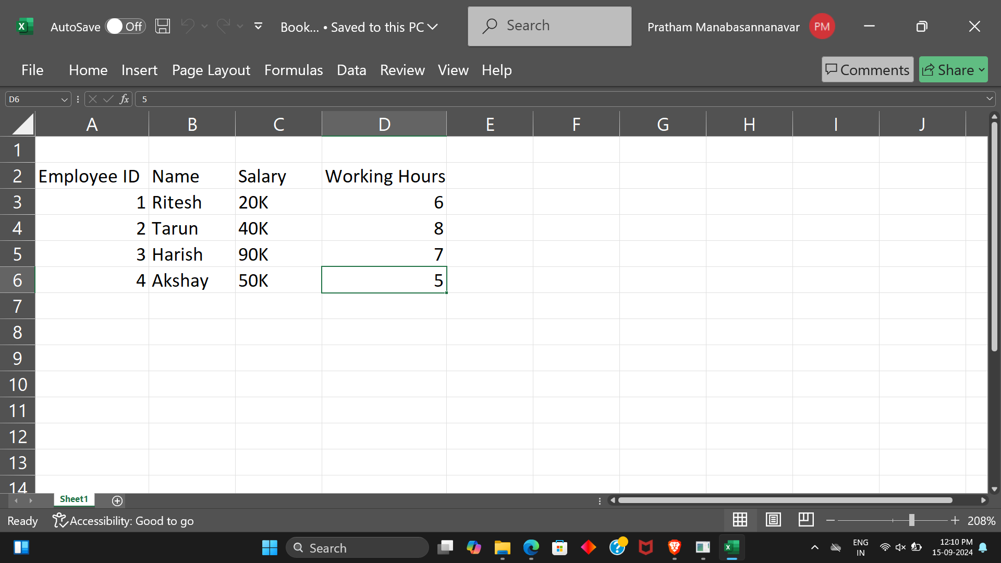

Figure 3.3 – Excel sheet to perform R/W operations